**DATABASE TABLE FOR MYWEBDESIGN**

**Show all tables:-**

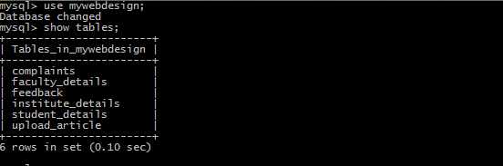

**institute_details:-**

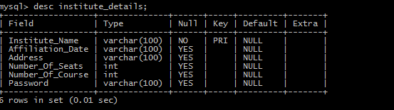

**student_details:-**

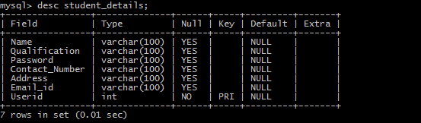

**faculty_details:-**

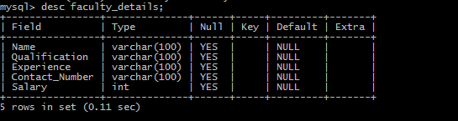

**feedback:-**

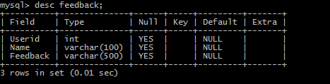

**Complaint:**

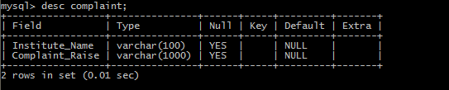

**Upload_article:**

